Literature Review and Dataset Selection

Team ASK
Westcliff University
DATA200 Applied Statistical Analysis
Professor Regmi
January 18, 2026

Literature Review and Dataset Selection
The study of factors which affect student academic performance is a big research issue in educational data mining and applied statistics. Schools are also becoming more and more dependent on data-driven practices to find struggling students, enhance student achievement, and to distribute school resources. The statistical and predictive models including linear regression model, logistic regression model, and classification model are beginning to be used in an attempt to analyse the effects of attendance, study habits, socioeconomic background, and behavioural factors on academic performance. The presented project is the continuation of an earlier study because it uses statistical analysis and predictive modelling on a real-world student performance dataset acquired through Kaggle.
Dataset Selection
We selected a dataset about students' academic performance from kaggle which contains organized, student-level records where each row represents an individual student along with their demographic information, family background, study behaviors, and academic outcomes. It includes variables such as age, gender, school type, parental education, daily study hours, study methods, internet access, attendance percentage, travel time, extracurricular participation, subject-wise marks (Math, Science, and English), and overall performance scores and grades.
By combining behavioral, environmental, and academic factors in a clean and consistently formatted structure, the dataset provides a comprehensive view of the elements that influence learning outcomes. This makes it highly relevant to our project, as it enables meaningful exploratory analysis and supports the application of statistical and predictive models to understand and forecast student academic performance.

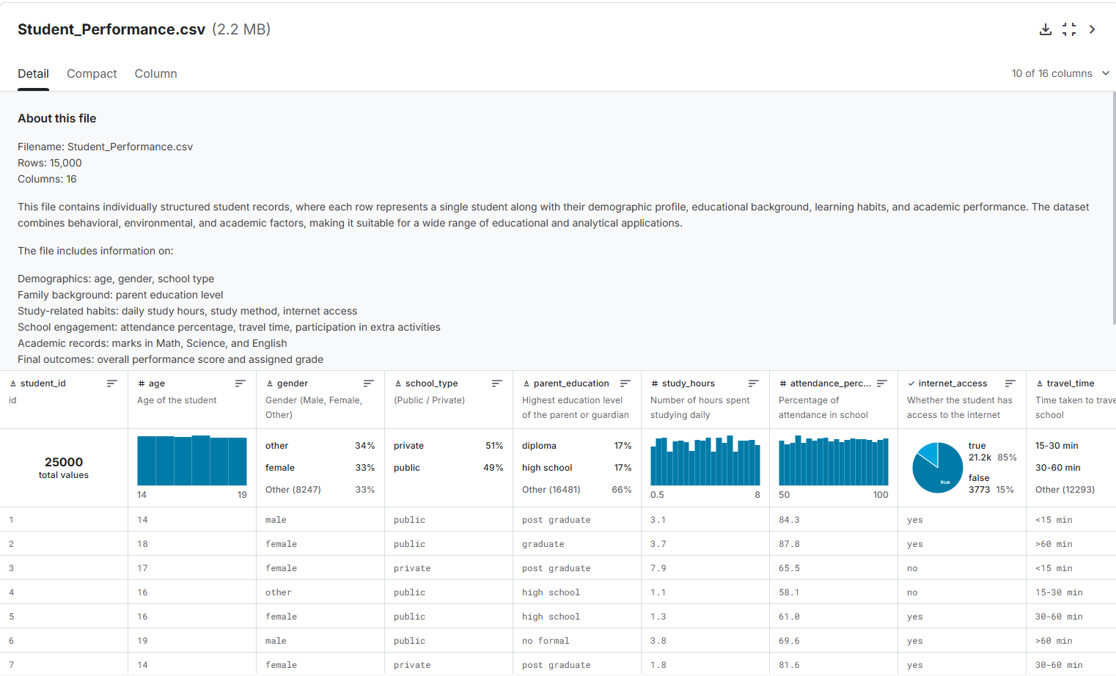
Dataset selected from Kaggle
Literature review
Article 1 - Educational Data Mining for Performance Prediction: Romero, C., & Ventura, S. (2010)
Romero and Ventura (2010) reviewed the application of educational data mining techniques to analyze student behavior and academic results. Their study highlighted that regression, classification, and clustering methods can uncover hidden relationships between attendance, participation, and grades. They emphasized that early prediction models help educators intervene before academic failure occurs. This supports our project’s objective of predicting performance using statistical techniques.
Article 2 - Factors Influencing Student Achievement: Cortez, P., & Silva, A. (2008)
Cortez and Silva (2008) analyzed Portuguese secondary school students using regression and classification algorithms to predict final grades. They found that prior grades, study time, failures, and absences significantly impacted performance. Their results demonstrated that simple statistical models can achieve strong predictive power, validating the use of linear regression and logistic regression for educational datasets. Their methodology closely resembles our chosen dataset and modeling approach.
Article 3 - Socioeconomic and Behavioral Impacts: Sirin, S. R. (2005)
Sirin (2005) conducted a meta-analysis on the relationship between socioeconomic status (SES) and academic achievement and the findings indicated a strong positive correlation between SES and performance, suggesting that background factors are critical predictors of success. This supports including variables such as family background, parental education, and school support in our analysis to better understand student outcomes.
Comparison
Across the following research study we find several common themes. First, all studies confirm that student performance can be effectively predicted using statistical and data-driven approaches. Second, behavioral factors such as study time and attendance consistently show strong influence on academic outcomes. Third, demographic and socioeconomic characteristics also contribute significantly to performance differences among students.
While Romero and Ventura (2010) focused on a broad range of data mining techniques, Cortez and Silva (2008) demonstrated the effectiveness of simpler regression models, and Sirin (2005) emphasized the importance of background factors. Together, these findings suggest that combining behavioral and demographic variables within interpretable statistical models is a practical and reliable approach. However, many prior studies relied on limited datasets or focused mainly on classification rather than explanatory modeling. Our project aims to address this gap by applying thorough exploratory analysis and regression-based modeling to a comprehensive student dataset.

Conclusion
The reviewed research collectively shows that statistical and predictive modelling techniques are valuable tools for understanding and forecasting academic performance and factors such as study habits, attendance, and socioeconomic background consistently influence outcomes and should be incorporated into predictive models. These findings provide strong justification for selecting the Kaggle Student Performance dataset and applying regression-based methods in our analysis. By building on established research, this project seeks to generate meaningful insights that can help educators make informed, data-driven decisions to support student success.

References
Cortez, P., & Silva, A. (2008). Using data mining to predict secondary school student performance. Proceedings of the 5th Annual Future Business Technology Conference, 5–12.
Romero, C., & Ventura, S. (2010). Educational data mining: A review of the state of the art. IEEE Transactions on Systems, Man, and Cybernetics, Part C (Applications and Reviews), 40(6), 601–618. https://doi.org/10.1109/TSMCC.2010.2053532
Sirin, S. R. (2005). Socioeconomic status and academic achievement: A meta-analytic review of research. Review of Educational Research, 75(3), 417–453. https://doi.org/10.3102/00346543075003417

